**Introduction**

The pDawn BL21 and pDusk BL21 are actually bacterial cells that already contain the pDawn and pDusk plasmids. This means that if you want to experiment immediately you can! Well first i would suggest propagating your cells so you have much more to experiment with but I can’t tell you what to do.

The basic premise is this, take some bacteria and spread it on an LB Agar plate. If it is pDawn, when you shine light on the bacteria for 8 hours or more or less(it depends on the temperature and strength of light and many other things so you may need to optimize it) and they will express the Red Fluorescent Protein(RFP) so much that the bacteria will look Pink/Red. If it is pDusk it should turn Pink/red in the dark but will be a normal White/Yellow color in the light. Controlling the light enables you to set up lots of different experiments in which you can regulate the frequency of light pulses and intensity of the light very precisely! Document your experiments and with pictures and experimental procedures and we will publish them on the website!

**Biosensors**

A biosensor is a set of DNA elements that work together to provide a desired output from an input. In this case the input is light detection by the YF1 protein and the output is the RFP. In this case the system is quite sophisticated and complicated but essentially works by YF1 activating the RFP gene to be made.

**Light Controlled Gene Expression**

The paper on the pDusk/pDawn system can be found [Here](https://drive.google.com/file/d/0B_R75gIJvkFUSkVlN3RFdmgzZ2s/edit?usp=sharing). Before we go into the experiments let me talk a little about how this system works. pDusk and pDawn are plasmids that contain the unique gene arrangements seen below.

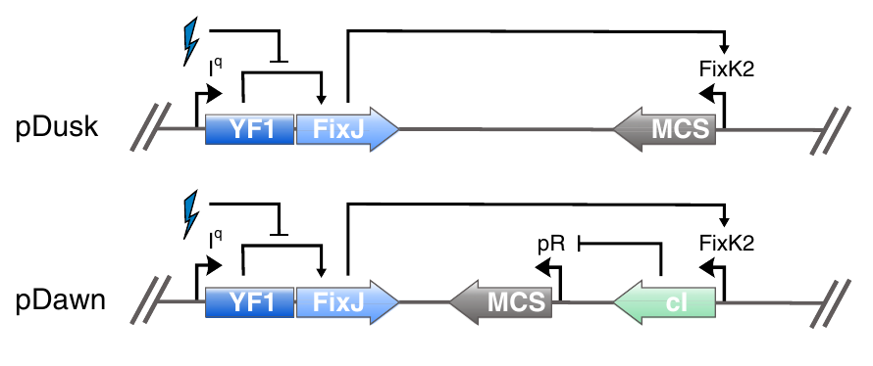

The basics of protein expression starting from DNA transcription and RNA translation can be found [Here](http://en.wikipedia.org/wiki/Central_dogma_of_molecular_biology). Understanding that DNA when transcribed creates RNA that when translated creates proteins and proteins are the functional machines in the cell.

In both our systems YF1 and FixJ are two genes that are expressed constantly from the LacI promoter(Iq). These form the basis of the light activated gene expression or suppression in pDawn and pDusk respectively. YF1 is a Histidine [Kinase](http://en.wikipedia.org/wiki/Kinase) that [phosphorylates](http://en.wikipedia.org/wiki/Phosphorylation) FixJ in the dark. It contains a Light-Oxygen-Voltage(LOV) domain that in response to light causes the YF1 protein to change structure and in this light activated structure it does not phosphorylate FixJ. FixJ binds to the FixK2 DNA binding site when it is phosphorylated which causes RNA polymerase to come and [transcribe](http://en.wikipedia.org/wiki/Transcription_(genetics)) the gene contained in the [Multiple Cloning Site](http://en.wikipedia.org/wiki/Multiple_cloning_site)(MCS). The MCS is a region of plasmid DNA that you put your gene. In our case, RFP is the gene in the MCS. If we follow the arrows in the diagram it shows that in the light(the lightning bolt) the phosphorylation of FixJ by YF1 is blocked in pDusk and pDawn causing NO transcription of RFP. How does pDawn work in the light then? Instead of the FixK2 promoter causing the expression of RFP it causes the expression of a repressor, the [lambda repressor](http://en.wikipedia.org/wiki/Lambda_phage#Repressor), which represses the gene expression of the RFP from another promoter(pR). In pDawn this means that the light stops the expression of a repressor that stops the expression of the RFP which means there is gene expression in the light!

So now that we know how these plasmids work let’s test them out.

1. First we need to start a culture of bacteria that contain the pDawn or pDusk plasmid. Take a clean inoculating loop and dip it into the bacterial stab bottle of pDawn or pDusk(only one at a time) and then into a 1.5mL tube with LB. Make a stock solution of 50mg/mL of Kanamycin and add 1.5uL(microliters) to the 1.5mL LB tube with bacteria.
2. The *E. coli* bacteria that we are using to control the genes contained in the pDawn and pDusk plasmids grow best at a temperature of 37C(~99F). They will also grow at room temperature but slower. If you do not have a temperature incubator at home there are a few simple ways you can build your own. Check them out [Here](https://docs.google.com/document/d/1LZGa5cgmFSzd14hn620NvuxW3EpL-KiEtp0UUURakmc/edit?usp=sharing).
3. Let the culture sit till it becomes cloudy(usually overnight or 12-24 hours).
4. Take 100uL using your pipette and spread it on a plate using a plate spreader or inoculation loop.
5. Set up an experiment where you shine light on some plates and don’t shine light on others.
6. Try and set up more complicated experiments where you change the length of time or amount of light used.

The Yellow but clear tube(Left) has no bacterial growth. The Yellow and cloudy tube(Right) has bacterial growth.

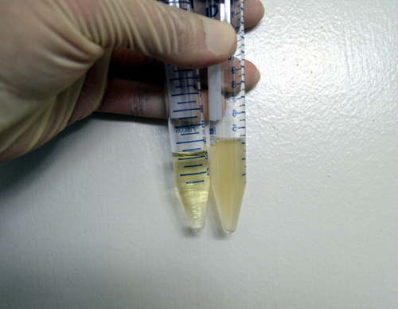

1. Make sure you shine constant light on the bacteria for 4 or more hours. On plates you can do other things such as shining light only on a specific part of the plate.
2. pDusk cultures will turn Red if you leave them in the dark and will stay Yellowish if you put them in the light.